Reflections about Your Conference Experience: Artifacts/Reflection Questions*

SAHE Program

Missouri State University

Introduction
Preparation program faculty have multiple reasons for encouraging SAHE graduate students to participate in Student Affairs professional conferences. The objective of this suggested reflection paper is to help you begin the process of unpacking your recent conference going experience at MOCPA, NACADA, ACHO-, ACUI, and UMR-ACHO state, regional, or national conferences.
I suggest that you create an outline to begin fostering deeper reflections about your conference going experience. Your outline toward becoming an emerging practitioner will occur through your efforts to connect all the “learning dots” of your education as a graduate student.
Your E-Portfolio will provide you a structure to identify and upload artifacts from different learning settings. These settings include faculty and peer interaction in the classroom; faculty/student mentorship; GA/full-time work interactions with professional and support staff; lessons learned from the site supervisor and your practicums; as well as your insight as a student into the professional conferences. Thus, developing deep reflections about your artifacts results in the creation of an exemplary E-Portfolio.
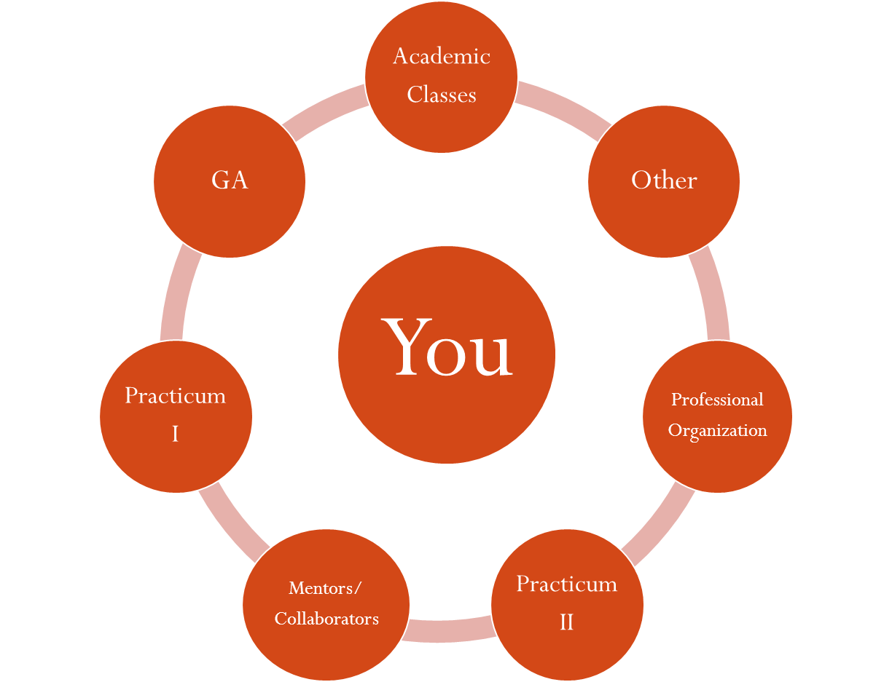
In the 721 and 723 classes, faculty share with you examples of how using Astin's IEO (inputs, experiences, and outcomes) model can help students develop deeper reflections about their graduate program experiences at MSU. I encourage you to make use of Astin’s model to think about your recent attendance and participation in professional conferences. In addition, you may want to make use of this activity to help you ponder over your learning in other educational related settings.

The following questions are organized around themes sometimes associated with graduate students attending professional conferences. The following questions may be more helpful to some students than other students.
Anticipated Outcomes
- What adjectives (warm, sunny, cold, partly cloudy, and chilly) would you use to describe your initial feelings about participating in the conference?

- Before leaving for the conference, what were your anticipated outcomes from participating in the conference?

- What are your impressions and feelings regarding your travel to and from the conference?
  - What are your thoughts and feelings about how traveling with peers will affect future interactions with peers after the conference?
  - What are your thoughts and feelings about how traveling with professionals from the Student Affairs Division will impact your interacting with them after the conference?
  - What are your thoughts and feelings about how this shared professional experience will impact your comfort level with interacting with professionals from the Student Affairs Division and program faculty?

The Next Generation
Attending a regional or national conference gives you an opportunity to interact with graduate student peers from other master’s preparation programs.
- How would you compare your synergistic (GA, classroom, peer interaction, practicum, and mentoring) experiences with your counterparts in other programs?
  - What are they doing that you think our program should focus on in subsequent years?
  - What are we doing that you think other graduate students would like their programs to pay attention in the future?

Program Content
- What are your thoughts and feelings about the conference program themes?
- Did the program themes speak to graduate students about higher education and student affairs?
- What are your thoughts about how presenters attempted to frame their programs in the ACPA/NASPA competencies?
- What are your perceptions and feelings about how the conference experience expands and enriches other components of your professional development?
- What are some unanticipated outcomes of your attending the conference?

Outcomes
- What didn't you like about your conference experience?
- What artifacts from your conference experience will contribute to the development of your E-Portfolio?
- What are your thoughts about how using Astin’s IEO Model or Baxter Magolda's Self-Authorship framework will help you further in unpacking your conference experience?

Other
The above questions did not address my thoughts and concerns about attending the conference.

* In fall 2012, O. Gilbert Brown developed the Reflective Structured Experience to partner with graduate students to help them develop deeper reflections about their learning in different settings, especially professional network settings.

